Consumer Credit Act Reform – Phase 1 Consultation
Response from Amplified Global Ltd.

18 July 2025

Response submitted to:
consumercreditact@hmtreasury.gov.uk

Introduction
Amplified Global is committed to assisting the FCA and HMT in designing rules that enhance clarity and intelligibility of disclosures, improve consumer trust and understanding, while providing opportunities to innovate.
We agree with the approach of repealing outdated CCA provisions and recasting these essential protections in FCA rules. This will foster flexibility, innovation, and better digital communication, while ensuring a focus on consumer outcomes rather than box-ticking compliance.

However, we also suggest a range of factors that will need to be considered to ensure that the changes:

- do not limit consumer protection or the ability of consumers to understand and compare products
- support widespread improvements in the currently low levels of intelligibility displayed in existing market disclosures
- work for all providers and market participants.

About Amplifi

Amplified Global is a small UK-based reg-tech / legal-tech company, and our tool Amplifi was developed to objectively assess and improve intelligibility. We help clients to present legal and regulatory information in a way that is more likely to be understood.

Our online tool objectively measures intelligibility. It enables users to identify specific barriers to understanding and then guides them to simplify written information and improve its intelligibility. The AI that underpins the Amplifi model has been established using extensive testing and proprietary research and accurately reflects the likelihood information will be able to be understood and applied by different readers.

We received direct Innovation Support from the FCA since 2019 to develop our intelligibility assessment capability. We have shared extensive insights from our research programme, as well as our time testing simplified regulated communications in the FCA Sandbox.

Summary

Amplified Global welcomes the opportunity to contribute to the reform of the Consumer Credit Act (CCA). We support the Government’s intention to modernise outdated provisions and recast essential protections under the FCA’s outcomes-based regime. This shift presents a valuable opportunity to remove unnecessary prescription, foster innovation in consumer communication, and raise the standard of intelligibility across the credit market.

However, to fully realise these benefits, reforms must be carefully designed to ensure they maintain strong consumer protection and enable meaningful improvements to consumer understanding and engagement.

A central challenge of the current disclosure regime is that the resulting consumer-facing information is often legally compliant but poorly understood. Low intelligibility undermines trust, comprehension, and effective decision-making.

The framework of rules should incentivise firms to prioritise simplification, encourage innovation in how information is presented, and enable the FCA to monitor, assess, and where necessary, intervene on the basis of objective measures of understanding. Amplified Global believes the introduction of a clear intelligibility standard, supported by testing, reporting, and guidance, would allow firms to demonstrate compliance in a consistent and outcomes-focused way.

Reforming the CCA is a unique opportunity to build a disclosure regime fit for the future: one that aligns clarity with fairness, protects consumers, and creates the space for responsible innovation to thrive.

Specific Comments

Question 1: Do you agree with our vision for a reformed regime?

Amplified Global supports the government’s vision to modernise the Consumer Credit Act.

The current regime, established in 1974, no longer reflects today’s digital-first lending environment. Simplifying and replacing overly prescriptive statutory disclosures with Consumer Duty-aligned, outcomes-based standards under the FCA can empower providers to deliver clearer, more intelligible and engaging consumer information. The proposed changes could better support continued innovation in credit products and improve consumer outcomes without compromising consumer protection. This aligns with our mission to enhance consumer understanding and engagement with often-complex financial and legal information.

While we support moving the bulk of CCA requirements into the FCA Handbook, the detail of the new rules and the degree of flexibility vs prescription will need to be carefully balanced to provide flexibility for firms, while protecting smaller credit providers from unintentional risks or cost. HM Treasury must ensure that consumers remain protected, and that the level of protection they receive does not diminish as a result of the changes.

Amplified Global runs a significant research programme focused on understanding what drives intelligibility and consumer engagement and understanding. We’ve looked at specific CCA prescription and industry practice that result in unnecessary complexity, and at how to address them. We have shared much of our research with the relevant teams at the FCA as part of the direct innovation support we receive, and we would of course be happy to share that with HM Treasury if that would assist.

Question 2: Do you agree with our preferred approach to legislation?

We support the proposal to make holistic changes in a single legislative process, rather than dividing the change-making into phases, as many of the issues are interconnected. Consideration of the new rules should be similarly holistic. However, that does not mean that bringing the changes into force needs to be taken at a single step.

It goes without saying that this process will result in significant change, for not just providers but for other market participants. Clarity and confidence around the transitional arrangements will be critical, and a clear understanding of how changing rules will apply to existing and backbook products, both during transition period and longer term, will be critical.

Question 3: Do you think the challenges in relation to the transitional provisions have been captured and what further thoughts do you have on possible appropriate transitional provisions?
The consultation captures many transitional challenges, particularly identifying which rights must remain legislated, versus those suitable for FCA oversight, and in the handling of historic non-compliance. We encourage the inclusion of clear transitional safeguards to:
- Honour existing consumer entitlements under the CCA during transition,
- Provide firms with adequate lead time to reconfigure disclosures and systems,
- Protect consumers caught mid-agreement by ensuring clarity on which regime applies.
Amplified Global recommends stakeholder engagement during Phase 2 to co-design pragmatic transitional rules, especially around legacy agreements and digital disclosures.

Question 4: Do you agree with our proposal to repeal the information provisions from the legislation and for these to be recast as appropriate into FCA rules?

Yes, we fully support repealing the CCA’s rigid information requirements and recasting them into FCA rules. The current rules concerning the format, prescribed language and process of presenting key information to consumers is overly technical, inconsistent, and often hinders consumer understanding. This is particularly true when firms seek to communicate in digital form.
At present, the CCA-led rules set continues to be the dominant influence on how firms communicate pre-sales information, terms and conditions and the agreement, as well as post-sales communications. These rigid disclosure rules often work at odds to the Consumer Duty requirement to simplify and improve the intelligibility of communications. This misalignment of the different rulesets enables some firms to justify why their terms are still unnecessarily complex.
The CCA ruleset and prescription does negatively impact on intelligibility and consumer understanding. However, it is not the only factor – there is still a lot more that many firms could do to improve the intelligibility of their communications and thereby meet the obligations under existing FCA rules and the Consumer Rights Act.

In the image below, credit card terms and conditions (downloaded from company websites on 4 July 2025) were assessed to vary widely in how intelligible they were, despite containing a very similar range and depth of information.

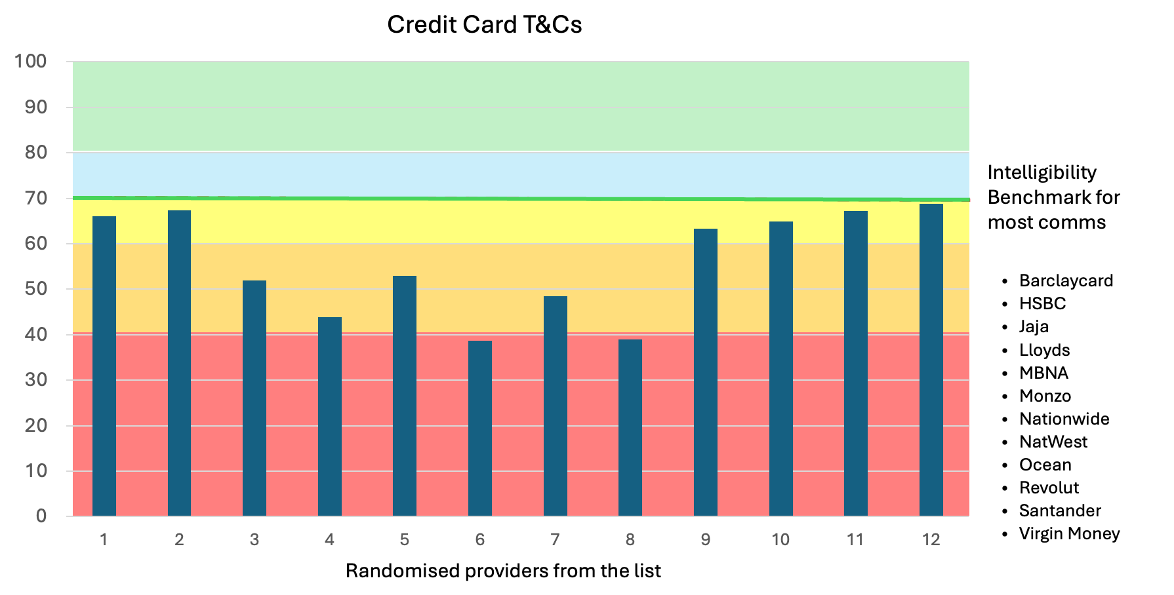

None of the agreements we tested met what we would consider as being a satisfactory level of intelligibility (the Amplifi Intelligibility Score ranges from 0-100, from least to most intelligible, and a common benchmark for most communications we test is 70+).

However, the results ranged widely. The best we tested scored in the high 60s. Despite the current levels of prescription these are relatively intelligible, likely to be understood by 70%+ of the adult population.

The worst scored below 40. We would consider these to be in a high-risk category, and a conceptually challenging read. These would be fully understood by only around 30-40% of adults.

The new rules should remove some of the glass ceiling that exists as a result of prescription. But unless the output from firms and the outcomes for customers are properly tested, by firms (and where necessary tested and enforced by the FCA), some poor understanding outcomes will continue for consumers.

Therefore, we welcome an update to the rules, and a rolling back of many areas of prescription. This will encourage innovation, allow better communications and remove the convenient excuse for firms to hide behind. But only with careful consideration of how to mitigate a number of risks:

- Some degree of prescription will need to be retained in the new FCA rules, to ensure that a common range of information is presented in a way that makes comparing costs and features of products simple for consumers.

- While we welcome the opportunity that the review will present firms and their suppliers to innovate, for some small firms this can be an expensive process. The existing prescribed format and information provides them with a template (even though it is not effective in encouraging engagement and understanding). There should be consideration of how to protect small providers in particular to have some access to a standardised, permissible (but intelligible) approach, or the development of products to support their compliance.

- One of the biggest challenges (but one of the most positive in our opinion) is to move much closer to an outcome-focused regulatory framework. But this requires several things to ensure high standards are reached as widely as possible:

  - Firms must be expected to provide evidence of the testing and tailoring they undertook to their communications, why they believe their disclosures are likely to be understood and support comprehension, and the outcomes customers are receiving.
  - More clarity needs to be provided by FCA in terms of good practice, effective testing procedures (e.g. comprehension testing), how to measure intelligibility across a wide range of factors, and the reporting expected of firms.
  - A strong and visible enforcement regime must be in place. To date there has been little jeopardy evident for firms that have still not simplified their legal and regulated communications, despite the Consumer Duty being in force. This has to change.

Question 5: Do you agree with our conclusion that the FCA regime without sanctions provides robust consumer protection?

The regime under FCA will include a number of protections for consumers, principal amongst them the requirements of the Consumer Duty, and whatever reporting and compliance obligations that will be built into the new provisions in the FCA Handbook.
We recommend ongoing monitoring and evaluation to verify whether redress remains timely, proportionate, and accessible under the new structure.

One of the principal protections consumers will have is in ensuring that disclosure is effective through ‘upstream’ measures – principal amongst these ensuring that all disclosures are intelligible, and accessible. Creating better guidance, and a standard around how firms can achieve and test intelligibility would help to ensure that a range of potential consumer risks are dealt with at source.

However, that will only work with firms that work towards the consumers’ best interests, or for whom the jeopardy of potential sanctions is a sufficient means of persuasion to improve their operations. But that is not true of all providers – therefore some more stringent downstream measures will need to be considered.

The proposed reform of the CCA includes removing automatic sanctions for non-compliance with information requirements. We note that organisations like Money Advice Trust have concerns that removing automatic sanctions could lead to increased instances of poor behaviour from less reputable lenders.

Sanctions should be proportionate to the severity and impact of the failure. Under a less prescribed disclosure regime it may be more challenging to apply sanctions based on failures to disclose in line with the more flexible requirements. We strongly suggest HM Treasury and FCA consider whether objective intelligibility measures would help firms understand what good looks like, and help the FCA to identify poor and unintelligible disclosures. This could work in tandem with sanctions tied to poor outcomes for consumers, which are typically identified much later, further down the consumer journey, usually after the consumer harm has already occurred.

Question 6: What are your views on the following approaches for criminal offences? Officials would need to review these options in the context of the wider CCA Reform proposals.

(a) Repealing all the criminal offences in the CCA, allowing the FCA to take enforcement action where possible;

(b) Keeping all the criminal offences in the CCA;

(c) Repealing all criminal offences (allowing the FCA to take enforcement action where possible) except those that relate to minors and canvassing off trade premises where criminal offences would remain.

No comment.

Question 7:
a: Has this paper captured the key issues and barriers for each of the cross-cutting themes of:

• Green Finance: No comment

• Islamic Finance: No comment

• Technology:

We broadly agree with the broad areas of focus for the Phase 2 review highlighted in the consultation, including complexity in digital and electronic communications, electronic signatures and digital contracts, and more flexible, less
prescriptive consumer journeys and communications.

b: Is there anything else you think needs to be considered in our Phase 2 policy work? [free text]

No comment.

Question 8: Do you agree with the provisional assessment that, on balance, the Government's proposed proportionate approach to reform mitigates the negative impacts on those sharing particular protected characteristics and retain the positive equalities impacts of the products?

Overall, reforms that lead to a disclosure regime that is more flexible, tailored, and simplified will help firms to support those with characteristics of vulnerability, and lead to greater engagement and access to financial services.

The dangers of information being omitted from disclosures under a more flexible regime is not an inevitable result of the reforms.

Flexibility can be focused more on ‘how’ information is being communicated, and the manner and format that it is set out for consumers, but not necessarily ‘what’ information is required to be provided. The current range of information may not be the core concern, merely the manner and simplicity with which it is communicated, the prominence given to some information over others (which can be a more dynamic factor in future focused on consumer needs, the timing of disclosure and the customer’s characteristics).

Question 9: Do you have any further data you can provide on the potential impacts on persons sharing any of the protected characteristics?

The Amplifi intelligibility assessment tool is able to assess how understandable information is likely to be to groups with different characteristics of vulnerability – and the issues that lead to greater complexity for them.

We would be very happy to share examples of how information intelligibility differs between different groups and the methodology we have developed to test that, if it would be of interest to the HM Treasury team. Please contact us for further details.
Ewan Willars
On behalf of Amplified Global Ltd
ewan@amplified.global
July 2025

